Waterloo West High School
Wahawk Bands
2016 - 2017 Handbook

“Excellence is the consistent pursuit of perfection.”

2019-2020 Handbook

Jason Dobbs Danny Kleinheinz Luke Sanders
Co-Director of Bands Co-Director of Bands Co-Director of Bands
dobbsj@waterlooschools.org kleinheinzd@waterlooschools.org sandersm@waterlooschools.org

Waterloo West High School
425 E Ridgeway Ave
319.433.2721
www.WahawkBands.com

Table of Contents

Waterloo West Band Program
Wahawk Marching Band
Concert Band
Solo & Ensemble Festival
Lessons
Pep Band
Jazz Band
Symphony Orchestra
Musical Pit Orchestra
Music Theory
Jazz Improvisation
Music Performance
Grading Policy
Band Lesson Rubric
Drill and Music Notebook
Dot Book
Attendance Policies
Tardiness to or Absence from Rehearsal
Absence from Performance
Alternate Travel Plans
Rules and Regulations
School Owned Instruments
Uniforms
Band Letter 12
Schedule of Major Performances 13
Band Boosters 14
West High Instrument Rental Contract 16
Participation Contract 18

Waterloo West Band Program
The Waterloo West High School Band Program has a long tradition of excellence in music. The Wahawk Band prides itself on a well-balanced program with a focus on music education, performance and a commitment to teaching students how to succeed in life through hard work and a passion for learning. Ensemble offerings include the Wahawk Marching Band, Concert Band, Symphonic Band, Wind Symphony, Jazz Bands and Pep Bands. Students also have the opportunity to perform in a Solo & Ensemble Festival, Symphony Orchestra, and various honor bands.

Membership is open to all high school students who currently play a band instrument. The course is designed to give every student an equal opportunity to participate in the various aspects of the band program and enhance his/her musical growth through individual study and performance as it applies to his/her particular instrument. In addition, the student will be given the opportunity to appreciate music both as listener and performer.

Students participating in the Wahawk Bands are able to participate in any other activity West High offers. Accommodations are made by the directors and other teachers/coaches to allow students to be actively involved in a variety of activities.

Wahawk Marching Band
The Wahawk Marching Band is a highly successful competitive marching band. The band performs for all West High home football games as well as five to seven competitions across the state. This fall, the ‘Wahawk’ Marching Band will perform at:
- Linn-Marr Marching Festival – Marion
- Bands Across the Prairie – Cedar Rapids
- Five Seasons Marching Festival – Cedar Rapids
- IHSMA State Marching Band Festival – Waterloo West
- ValleyFest Showdown – Valley Stadium, West Des Moines
- Mid-Iowa Marching Championships, Ankeny
Students rehearse periodically throughout the summer with rehearsals scheduled by directors, marching band staff, or section leaders. A Freshman Orientation is held the Friday prior to Band Camp starting to kick off the Fall Season. Band Camp begins the two full weeks prior to school starting, with rehearsal from 9:00 AM - Noon and 6:00 to 9:00 PM (dates included on Summer mailing). Band Camp will be followed by three night rehearsals, 6:00 PM – 9:00 PM. At Band Camp, students learn and memorize music, drill, and marching fundamentals so that future rehearsals can be used to clean and refine the marching band show. An Open House and Picnic are also held.

The Wahawk Marching Band rehearses daily from 7:15 AM through the first period of the school day and one evening per week (Monday/Tuesday 6:00 PM - 9:00 PM). Additional rehearsals may be scheduled if the need arises. Rehearsals will occur on the West High School practice field and in Kersenbrock Auditorium at West High.
Concert Ensembles
The Waterloo West Band Program has three concert bands split by grade level and/or audition. Wind Symphony is an auditioned ensemble of 10-12 grade students and meets during Period 1. Symphonic Band is comprised of students in grades 10-12 and meets during Period 1. The Freshmen Concert Band consists of 9th grade students and meets during the school day. . Additional or extended rehearsals may be scheduled as needs arise. This information will be posted on the calendar.

The Concert Ensembles perform at six events throughout the year. Three concerts are held in Kersenbrock Auditorium at West High School in December, February, and May. All of the ensembles participate in the IHSMA State Large Group Festival in May at Cedar Falls High School and an end-of-the-year Pops Concert at the RiverLoop Amphitheatre in downtown Waterloo. Additionally, all sophomore and junior band students perform at the Graduation Ceremony at the McLeod Center in May.

Solo & Ensemble Festival
All students in the Waterloo West Band Program have the opportunity to participate in the IHSMA Solo & Ensemble Festival in April in either the Waterloo or Dubuque areas. The directors will confer to place the students in ensembles of appropriate size, instrumentation, and ability level.

Lessons
Students receive regular individual 20-25 lessons during the semester. The grading periods are: mid-term, quarter, mid-term, semester). A sign-up sheet is posted each week on the bulletin board in the Band Room for students to schedule these lessons. Credit will be given for no more than one lesson per week. Students should be better aware of good/bad times to come out of class than the directors. While the directors are keeping track of which class students are missing, students are responsible for all work in these classes. Students who study privately may obtain a Lesson Waiver from one of the directors. This form will need to be signed by their private lesson teacher and returned for a grade. A grading scale for lessons can be found on page 7.

Pep Band
The Wahawk Band actively supports the West High Basketball teams by performing at twelve different home games. Students are assigned by the directors to one of two pep bands that perform at these home games. These assignments are to ensure proper instrumentation and experience level in both ensembles. Students are expected to perform or find a substitute of the same instrument for each of their pep band’s six performances. This is part of their band grade. Band points will be awarded to students who perform beyond their required five performances. Students cannot make up missed performance by attending performances of their non-assigned band.

Jazz Band
The Waterloo West Band Program has two auditioned large jazz ensembles: Jazz I and Jazz II, and a third, non-auditioned Jazz group. Jazz I is made up of the more advanced jazz players; every student will work on improvisation and advanced ensemble skills. In Jazz II, students will focus on the basics of jazz style and improvisation. Jazz III focuses on jazz basics.

Auditions occur in mid-October near the end of the marching band season and are an assessment of the students’ current jazz skills. The specific expectations and requirements for these auditions will be made available prior to the end of the marching band season, but students can expect to be asked to sight-read, play scales, and improvise.
Jazz I and II participate in (Jazz III may not attend contests):

- Jazz Band Concert in December – Waterloo West High School
- Tallcorn Jazz Festival in February - University of Northern Iowa
- Coe College Jazz Festival in February - Coe College, Cedar Rapids
- NEIBA Jazz Festival in March - Waterloo West High School
- Iowa Jazz Championships at the end of March – Civic Center, Des Moines IA(if qualify)
- “Jazz and Dessert” in April - Waterloo West High School Commons

Each week, the jazz bands rehearse twice a week set up by the Directors.

Instruction and assignments for the jazz ensembles will focus on aural skills, listening to jazz, building jazz vocabulary for improvisation, and preparing the ensemble parts.

Symphony Orchestra
Wahawk Band students have the opportunity to perform with the Symphony Orchestra at West High. The orchestra and band directors will solicit musicians. This need is determined by the literature selected to be performed. This schedule will be posted on the calendar.

Beginning/AP Music Theory
Music Theory is a semester-long course offered when there is an adequate level of student interest. Students will build their knowledge of basic music theory concepts. This course will emphasize material in the areas of musical notation, major and minor key signatures, scale construction, chord construction, musical and rhythmic dictation and the realization of two part voice leading. Students will develop a sense of self-discipline required for the study of music, a sense of relative pitch, verbal musical literacy, and the ability to listen actively. AP Theory covers more advanced Music Concepts for students who wish to study music after high school.

Jazz Improvisation
Exploring abstract elements and essential functions of improvisation, this semester-long course stresses rudiments of jazz chord and scale spellings, chord/scale/mode relationships, jazz nomenclature, basic forms, and phrase construction. Aural training, including transcription of recorded jazz solos, will be emphasized. Class performance will focus on the blues form, as well as jazz standards with simple progressions. If an appropriate instrumentation can be assembled, the class can also function as a small jazz ensemble to perform at school and community events.

Grading Policy
The grading policy for the Wahawk Bands incorporates many different elements to allow each student the maximum possibility of success. The elements are broken down as follows:

BAND LESSONS: 42%

PERFORMANCE: 38%

WRITTEN WORK: 20%

Band Lesson Rubric

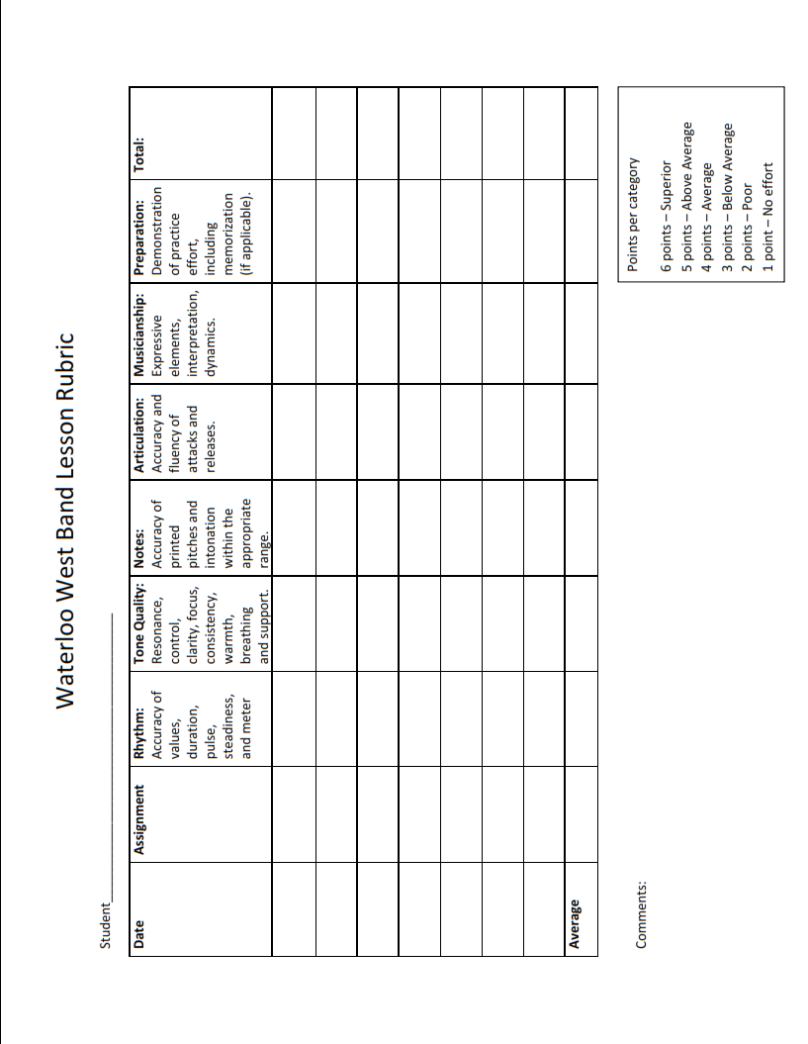

Drill and Music Notebook
Each student is required to have a hardbound 3-ring binder with his or her name and individual number clearly marked on the outside cover. This notebook will contain:

- All Marching Band Music (Pre-Game, Half-Time, and Pep Band). Music will be marked clearly and correctly with drill instructions and musical expressions.

- Clear, plastic protective sheets to hold music and drill.

- Pencil

Dot Book
Each student is required to have a dot book (approximately 3” x 5”) with a string attached and his or her name and individual number clearly marked on the outside cover. This dot book will contain:

- Individual coordinates for the student’s position for each drill set. (1 drill chart per page).

- A 3” x 5” cutout of the drill pasted in the dot book including the directions, measure numbers, and counts.

- An indication of which yard lines (if any) are crossed and on which counts they are crossed. (a formula to calculate this will be given during band camp)

The Drill and Music Notebook and Dot Book are the Instrumental Music Project for the marching band season. Students are expected to have BOTH books at EVERY rehearsal. Assignments will be given from these books periodically throughout the season. An alternative assignment will be made for drum majors and pit percussionists.
Attendance Policies
Band members are required to attend all rehearsals and all performances for the full scheduled time. Students will be on time for all band functions. To be “on time” means to be in the designated location, with all necessary materials, ready to go prior to the assigned time. Being on time and present at rehearsals and performances is the most important thing you can do for the band.

Tardiness to or Absence from Rehearsal
Attendance is taken at the beginning of each rehearsal. Attendance and tardiness will have a direct effect on the student’s grade. As soon as students or parents become aware of any potential conflict with a rehearsal time, they are asked to e-mail the directors immediately (kleinheinzd@waterlooschools.org, dobbsj@waterlooschools.org, sandersm@waterlooschools.org ).
If a student has two or more unexcused absences from rehearsals the week of a performance, that student will be placed on an alternate status for a performance (will attend, but will not perform).

Absence from Performance
Attendance at ALL performances is mandatory. Except in cases of extreme emergency, (death in the family or illness), students WILL NOT be excused from a performance. Any written excuse must be written, signed, and dated by a parent/guardian stating the student’s name and cause of absence seven (7) days prior to the absence. All excuses will be placed in the student’s personal file. Any absence that is not brought to the director’s attention for approval prior to the performance will be considered unexcused. All absences must be approved by the directors.

Alternate Travel Plans
Occasionally the need arises for a student to find a way two or from an outside performance/competition other than riding the bus with the rest of the students. If this is the case, an Alternate Travel Plans form must be filled out, signed, and returned prior to the event. Alternate Travel Plans forms will be included on the Band website.
Rules and Regulations
- Students will bring instruments, music, and proper equipment to EVERY rehearsal or performance.
- Students will be at the designated location and ready to rehearse or perform prior to the designated start time.
- Unauthorized use of cellular phones and other electronic devices are not permitted during any rehearsal or performance. These items will be confiscated by the directors.
- Eating or drinking of any kind during any rehearsal or performance is not permitted in the Music Area.
- Daily announcements will be posted on the bulletin board. Students are expected to check these announcements for instructions on rehearsals, performances, etc. prior to asking the directors. Students are not allowed to write on or remove information from the bulletin board.
- Music folders, instruments, and equipment will be kept in the proper storage places when not in use. Any items not stored properly will be confiscated by the directors.
- Non-music related materials are not allowed in the Music Area. These items will be confiscated by the directors.
- The Music Area is for practicing, rehearsing, and performing music. Students using the area for other activities will be asked to leave.
- Percussion instruments may only be used by percussionists and in a proper manner.
- Students must have permission from a director to enter the Music Offices.
- Personal belongings are not secure in the Music Area. Please store them in your locker.
- Do not litter in the Music Area.
- Vandalism, destruction or theft of school or personal property WILL NOT be tolerated.

Any violation of the above rules and regulations may result in confiscation of materials, a referral, or detention.

School Owned Instruments
Students using school owned instruments will take ALL responsibility for the care and maintenance of that instrument. There will be a rental fee of $50.00 per year assessed to each student for each school owned instrument (e.g. marching mellophone and concert french horn = $100.00). Percussionists will be assessed a $50.00 fee to defray the cost of replacement heads, mallets, etc. Wind players performing on percussion instruments during the marching band season will only be assessed a $25.00 fee. Instruments will be issued to students in working condition. Students are responsible for ALL repair costs incurred while the instrument is in their care.
All students renting a school owned instrument must fill out an Instrument Rental Agreement found at the back of the handbook or on the website.

Uniforms
At the beginning of the school year, students will be issued a marching band uniform and a concert band uniform to be used at performances and competitions.

Marching Band Uniform
- Uniform Coat (with sleeved, white T-shirt underneath)
- Uniform Pants (with athletic shorts/tights underneath
- Hat/Beret and Shako
  - Hat is worn 2 fingers above the nose
  - Long hair must be tied up or braided under the hat
- Black Marching Shoes
- Black Socks (calf-length or longer, not provided)
- Black Gloves (fingertips cut for flutes and clarinets)

Concert Band Uniform - Men
- Black Tuxedo Jacket
- Black Tuxedo Pants
- Bow-Tie
- White Tux Shirt (with sleeved, white T-shirt underneath, not provided)
- Black Socks (calf-length or longer, not provided)
- Black Dress Shoes (not provided)

Concert Band Uniform - Women
- Black Concert Dress (worn with a slip)
- Black Shoes (heels or flats, no open toes, not provided)
- Nylons (not provided)

Jazz Band Uniform – Men (not provided)
- Dress Shirt (optional dark suit jacket)
- Tie (necktie)
- Dress Pants
- Dress Shoes
- Dress Socks
- Belt

Jazz Band Uniform – Women (not provided)
- Dress Shirt and Dress Pants
- Dress Shoes
- Dress Socks

Uniform Rules and Regulations
- Students are responsible for the proper care and maintenance of the uniform.
- The uniform is NEVER to touch the ground. (sitting, placing, etc.)
- No eating or drinking when in uniform.
- Students are either in full uniform or out of full uniform. Nothing in between.
Band Letter
Students are given the opportunity throughout the year to accumulate points toward a band letter. The directors will keep track of these points and award a West High Band Letter to those students that have met the criteria. Listed below are ways in which a student may earn/lose points through participation. An emphasis is placed on performance aspects of the program.

Jazz Band 30 points

Pep Band 5 points per additional performance

Symphony Orchestra 10 points per performance

Musical Pit Orchestra 15 points

All-State Audition 10 points

All-State Band/Orchestra 20 points

NIEBA Honor Band 15 points

Solo & Ensemble Contest 15 points per performance

Concert Attendance 5 points each submitted program

Outside Performances 10 points per performance

Band Volunteer Opportunities 5 points per event
(10 point max – student)
(10 point max – parent)

Unexcused Tardy to Rehearsal -2 points for each offense
- including Band Camp
Unexcused Absence from Rehearsal -5 points for each offense
including Band Camp
Unexcused Absence from Performance -15 points for each offense
including Band Camp

To earn a Band Letter, students must adhere to the following criteria:

- Total of 75 points or more for the school year
- Maintain a B+ average of higher in Band
Schedule of Major Performances
This is a tentative schedule. For the most up-to-date schedule, check www.WahawkBands.com
Day | Date | Start Time |  |  | End Time | Event – Location
Friday | August 30 | 6:00 PM |  |  | 10:00 PM | Home Football Game (Waterloo East) – Memorial Stadium
Friday | September 20 | 6:00 PM |  |  | 10:00 PM | Homecoming Football Game (Des Moines Hoover) – Memorial Stadium
Friday | September 27 | 6:00 PM | 10:00 PM |  |  | Home Football Game (CR Jefferson) – Memorial Stadium
Saturday | September 28 | ALL DAY |  |  |  | Linn-Mar Marching Invitational
Saturday | October 5 | ALL DAY |  |  |  | Bands Across the Prairie/Five Seasons Marching Festival – Cedar Rapids, Prairie HS/Kingston Stadium Cedar Rapids
Saturday | October 12 | ALL DAY |  |  |  | IHSMA State Marching Band Festival/ValleyFest –  Memorial Stadium/West Des Moines Valley
Monday | October 14 | 7:00 PM | 8:00 PM |  |  | 9th Grade Band Concert - West HS
Friday | October 18 | 6:00 PM | 10:00 PM |  |  | Home Football Game (CR Prairie - Sr Nt)– Memorial Stadium
Saturday | October 19 | ALL DAY |  |  |  | Mid-Iowa Marching Band Championships - Ankeny
Saturday | October 26 | ALL DAY |  |  |  | All-State Auditions - Hampton-Dumont
Thursday  Friday  Saturday | November 21  November 22 November 23 | ALL DAY |  |  |  | All-State Music Festival – Ames
Saturday | December 7 | ALL DAY |  |  |  | NEIBA Honor Band - Oelwein HS
Monday | December 9 | 6:00 PM |  |  | 8:30 PM | Winter Band Concert - West HS
Saturday | January 4 | ALL DAY |  |  |  | NEIBA Honor Jazz Band - CR Kennedy
Monday | January 21 | ALL DAY |  |  |  | IHSMA State Jazz Band – Union High School, LaPorte
Monday | February 17 | 6:00 PM | 8:30 PM |  |  | February Band Concert – West HS
Friday | February 21 | ALL DAY |  |  |  | Tallcorn Jazz Festival – UNI
Friday | February 28 | Time TBD |  |  |  | Coe College Jazz Summit – Cedar Rapids
Saturday | March 7 | ALL DAY |  |  |  | NEIBA Jazz Festival – West HS
Tuesday | April 7 | ALL DAY |  |  |  | Iowa Jazz Championships – Des Moines Civic Center
Saturday | April 18 | 7:00 PM |  |  | 8:30 PM | Solo & Ensemble Contest – Location TBD
Thursday | April 2 | 6:00 PM |  |  | 8:30 PM | Jazz and Dessert – West HS Commons
Monday | April 27 | 8:00 PM |  |  | 9:30 PM | Spring Band/Orchestra Concert – West HS
Saturday | May 9 | ALL DAY |  |  |  | IHSMA State Large Group Contest – Cedar Falls HS
Monday | May 11 | 6:00 PM |  |  | 8:00 PM | Band Banquet -West HS Commons
Wednesday– Saturday | May 13 –  May 16 | ALL DAY |  |  |  | IBA Conference (All State Jazz Band) – Des Moines
Tuesday | May 22 | 6:00 PM | 8:00 PM |  |  | Graduation - McLeod Center, UNI
Friday | June 12 | TBD |  |  |  | My Waterloo Days Parade - Waterloo

Band Boosters
The West High Band Booster club exists to:
1. Encourage excellence in music education and performance.
2. Support these efforts financially.
3. To encourage student, parent, and community participation in the band program.
4. To foster enjoyment of and encourage lifelong appreciation for music.

Membership is available to anyone interested in the progress and development of the Wahawk Bands. Participation in the Booster Club is limited to those with current, paid membership status. Current dues involve a small donation to the Booster Club. The Board of Directors consists of the Club Officers, Standing Committee Chairs, Parent Representatives, and Band Directors.

General meetings are normally held in the Band Room on the 2nd Thursday of the month and begin at 7:00 PM. Board meetings begin at 6:30 PM, prior to the General Meeting.

Committee listing of Parent names is listed on the Band website

West High Instrument Rental Contract

Please read the following statement, sign it and return this form to the instrumental music office. Both your signature and your parent or guardian’s signatures are needed. Failure to sign this statement does not alter the terms of the policies. The rental must be paid and this form signed before the student will be allowed to perform. The rental cost covers the entire school year.

I, the undersigned, do hereby agree to pay an instrumental rental fee to the West High Music Department for the use of school owned instrument(s) or equipment for the 2019-2020 school year. Furthermore, I accept all individual responsibility for the care and maintenance of said instrument(s) or equipment. Should any damage or abuse to the instrument occur during the year, I agree to pay the full cost to repair that instrument.

Instrument No. 1_________________ Instrument No. 2__________________

Model No.______________________ Model No. ______________________

Serial No.______________________ Serial No._______________________

___________________________________ _________________________
Student Signature Date

___________________________________ _________________________
Parent or Guardian Signature Date

Parent email address: ___________________________________________________________

Brass Rental $50.00 per instrument

Woodwind Rental $50.00 per instrument

Percussion Fee $50.00

Wind Player/Percussion Users Fee $25.00

Participation Contract

Please read the following statement, sign it and return this form to the Music Office by August 28, 2019. Both your signature and your parent’s/guardian’s signatures are needed. Failure to sign the statement does not alter the terms of the policies. This form must be signed and returned in order for the student to perform.

As a member of the West High School Band, I have read the information in this handbook and understand its contents. Furthermore, I agree to abide by the rules and regulations set forth by the Instrumental Music Department and exhibit behavior both in and out of school that makes me worthy to represent the ideals, principles and standards of our band program and West High School.

______________________________________ __________________
Student Signature Date

______________________________________ __________________
Parent Signature Date

Parent email address: ______________________________________________________

Make sure you also submit this email address on the band website, www.wahawkbands.com
under the Join Mailing List tab, so that you receive all of the important band updates and information.

